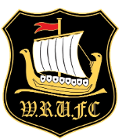
Windermere Rugby

Saturday 4th November
Annual
Fireworks
& Music
FIRE EATER
REAL ALE-HOT FOOD
MULLED WINE-BARS

3 Live Bands
BOOK NOW ADULTS £10 CHILD £5

FAMILY £20 (2 Adults 2 Child)

